Bibliography

Papers

[20] Extensible Entity Relationship Modeling

[9] Representing the XPath model in Relational Databases

[3] A General Technique for Querying XML Documents using a Relational Database System.

[4] Storing and Querying XML Data using an RDBMS

[5] Relational Databases for Querying XML Documents: Limitations and Opportunities

[21] CPI: Constraints-Preserving Inlining Algorithm for Mapping XML DTD to Relational

Books

XML Processing in Java

Practical Postgresql

SQL in 10 minutes (for standard sql instead of postgresql specific)

Essential XML Quick Reference

APIs

JDOM
XSD Infomodel
JGraphT

Manuals

PostgreSQL online manual

Websites

World Wide Web Consortium (W3C)
XML Schema structures | http://www.w3.org/TR/2004/PER-xmlschema-1-20040318/

W3 Schools
Apache XML Project (Xindice) – http://xml.apache.org/xindice/faq.html#faq-N1002B
XML Schema langauges
http://www.cobase.cs.ucla.edu/tech-docs/dongwon/ucla-200008.html

Appendix I
XML Schema grammar

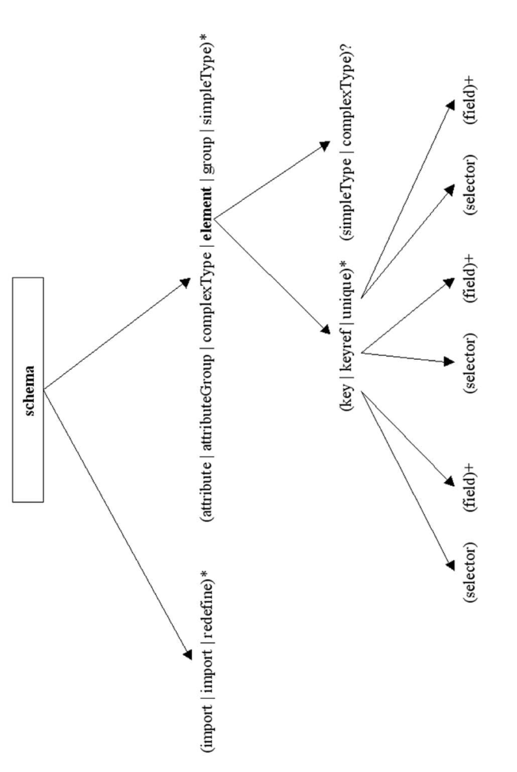
Note: Annotation has been omitted from the tree, but can appear as a child of any construct
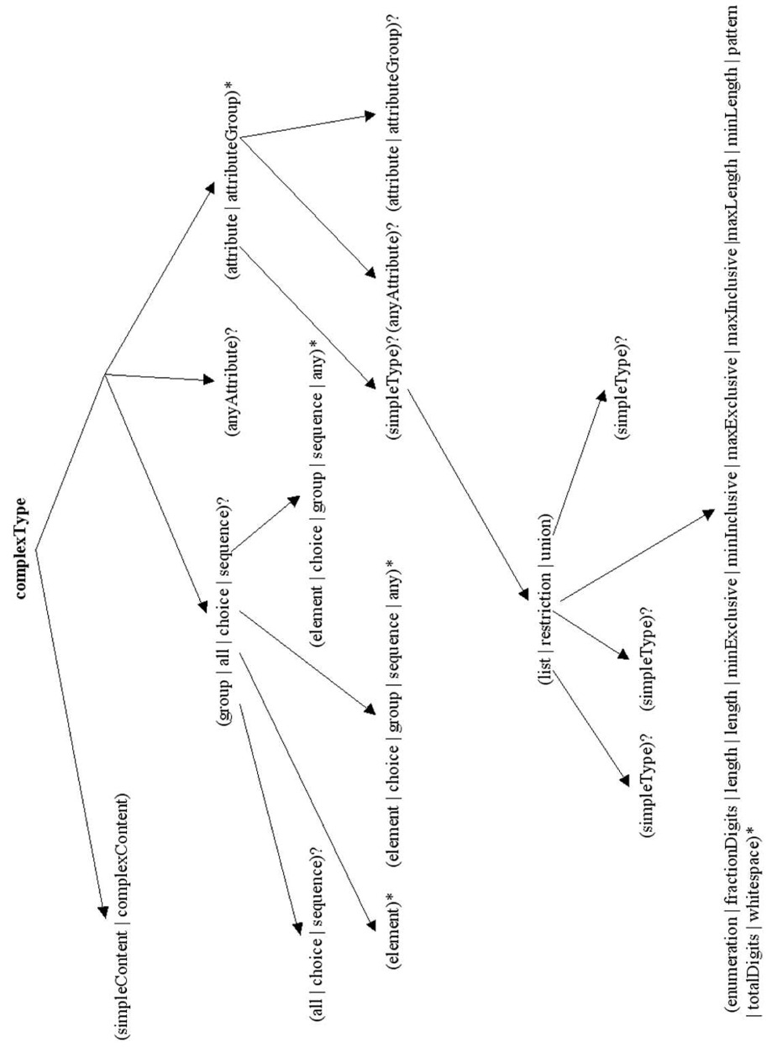

Appendix II
Catalog tables’ relational structures

[Also give a dump of these tables so that the sort of information can be seen]

catalog_attributes(attribute,element,alias)
catalog_elements(elmenet,parent_element,alias,type)
catalog_specializations(specialization,generalization)
catalog_generalizations(generalization,alias)
ids_to_tables(id,table)

generalizations also needs to contain an alias

elements catalog also needs to say for complex types whether

Glossary

User Guide

Program Listings
Talk about everything on the CD.

